|  |  |  |  |
| --- | --- | --- | --- |
|  | **Course Name: Design Patterns/Thinking LAB** | **EXPERIMENT NO. 10** | |
| **Course Code: 20CP210P**  **Faculty: Dr. Ketan Sabale** | **Branch: CSE** | **Semester: IV** |
| **(To be filled by Student)**  **Submitted by: Jangle Parth**  **Roll no: 22BCP083** | | | |

Objective: To familiarize students with standard Structural design patterns.

Experiment: Explain the Decorator design pattern and write a program using any object-oriented programming language to demonstrate the working of Decorator design pattern.

Theory: Imagine a Scenario where you own a tank manufacturing factory and you know also start polishing of tank in your factory as you are smart owner you know that creating a extra class of polished product would not be most efficient way so you create a abstract class Tank Finish which is responsible for creating diff kind of finished tank. This addition of a class which takes normal object and make it decorated is called is called Decorator design pattern

**Problem Statement Explanation:**

We have a Tank class which has a method create tank which is responsible for creating tanks. Then we have a decorator class like Glass Bead ,Polish etc. which add some decoration to the base product.

**Flowchart Explanation:**

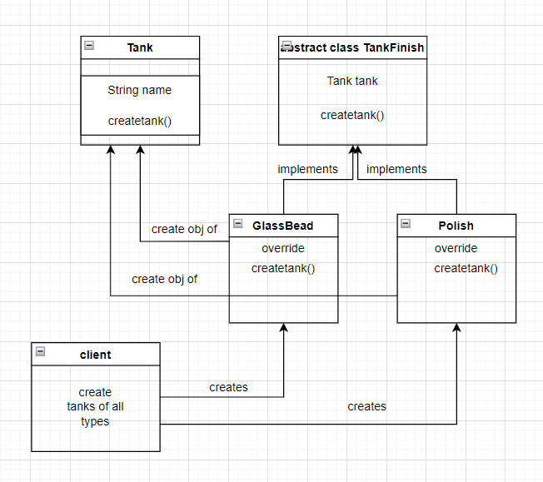

**Code:**

class Tank {

    String name;

    Tank(String name) {

        this.name = name;

    }

    public void createtank() {

        System.out.println();

        System.out.println(name);

        System.out.println("Created Tank");

    }

}

abstract class TankFinish {

    Tank tank;

    TankFinish(Tank tank) {

        this.tank = tank;

    }

    public void createtank() {

        tank.createtank();

    }

}

class GlassBead extends TankFinish {

    GlassBead(Tank tank) {

        super(tank);

    }

    public void createtank() {

        tank.createtank();

        System.out.println("Added Glass Bead Finish");

    }

}

class Polish extends TankFinish {

    Polish(Tank tank) {

        super(tank);

    }

    public void createtank() {

        tank.createtank();

        System.out.println("Added Polished Finish");

    }

}

public class decorator {

    public static void main(String[] args) {

        Tank t1 = new Tank("Milk Sotrage Tank");

        GlassBead t2 = new GlassBead(new Tank("Acid Sotrage Tank"));

        Polish t3 = new Polish(new Tank("Beer Sotrage Tank"));

        t1.createtank();

        t2.createtank();

        t3.createtank();

    }

}

**Output:**

